**NAME :** Vinit Nilesh Dharmale

**ROLL NO.:** ET2-08

**PRN :** 202401070200

**Cricket World Cup Dataset**

Find the total number of matches played.

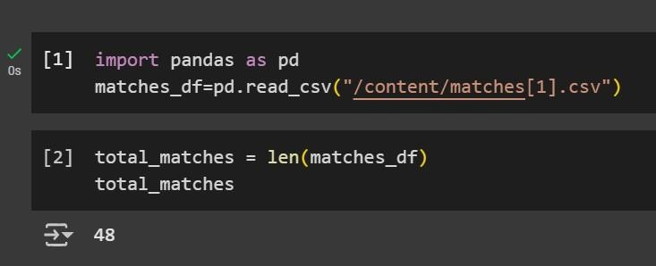

Identify all unique teams that participated.

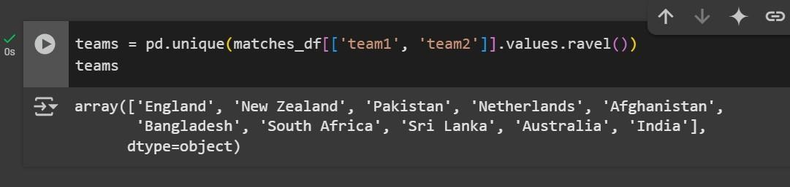

Find the number of unique cities where matches were hosted.

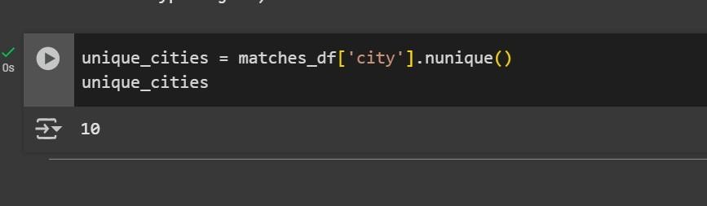

List all the venues where matches were played.

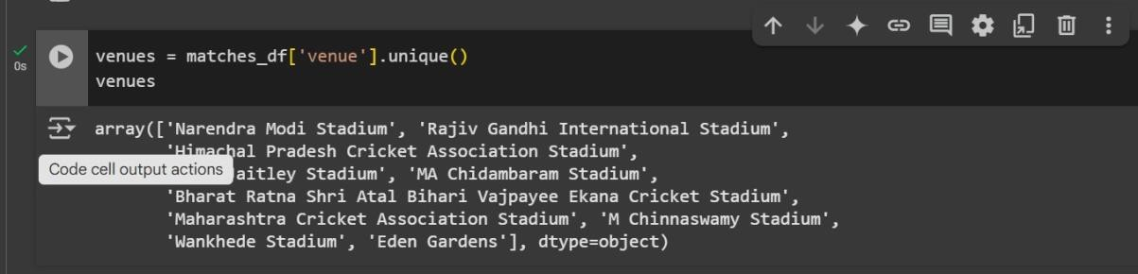

Find the number of matches each team won.

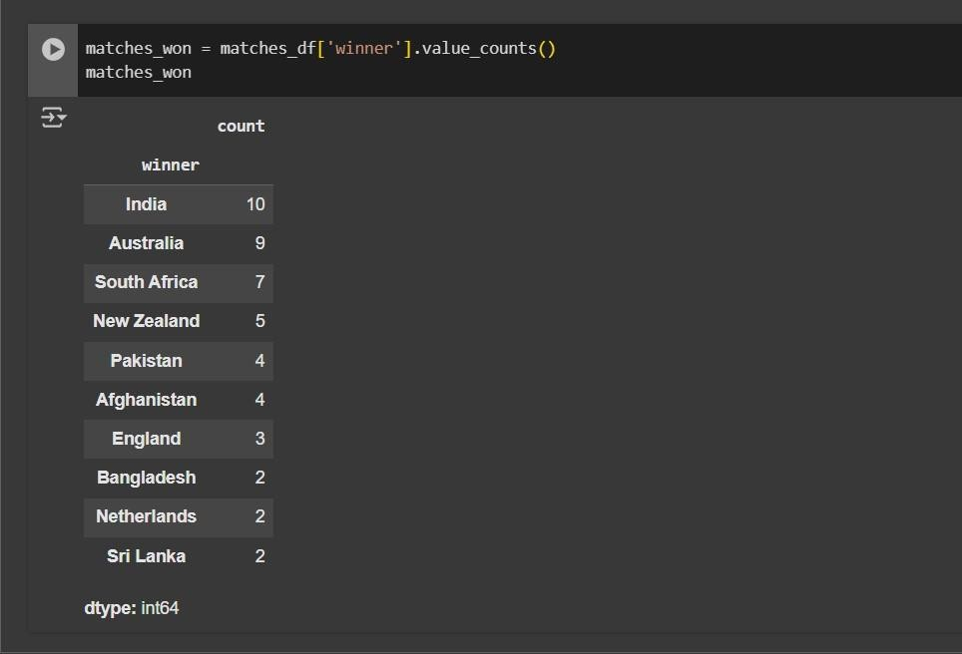

Determine the most common toss decision (bat or field).

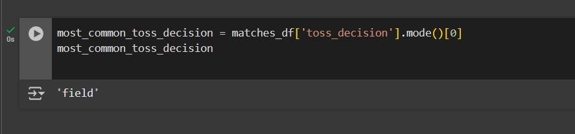

Identify the player with the most 'Player of the Match' awards.

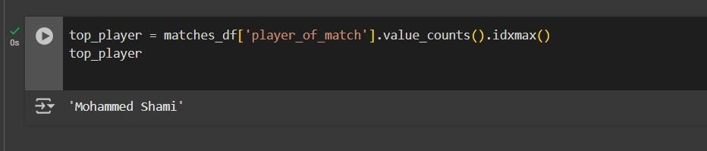

Find the match with the highest winning margin by runs.

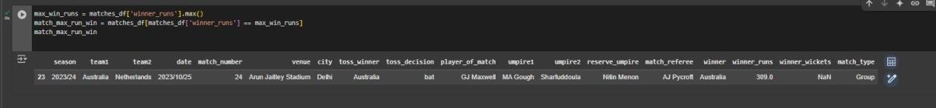

Find the match with the highest winning margin by wickets.

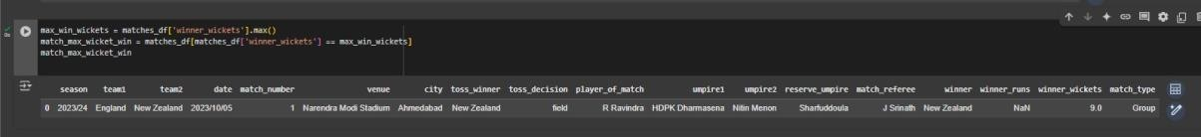

**Count how many matches were decided by runs and how many by wickets.**

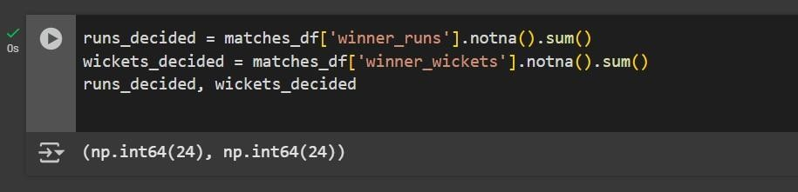

Find the city that hosted the most matches.

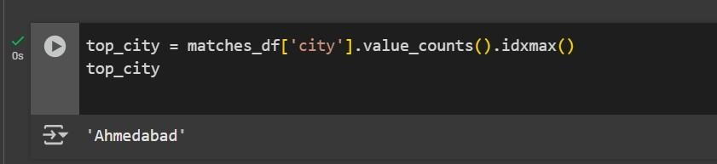

Find how many times the toss winner also won the match.

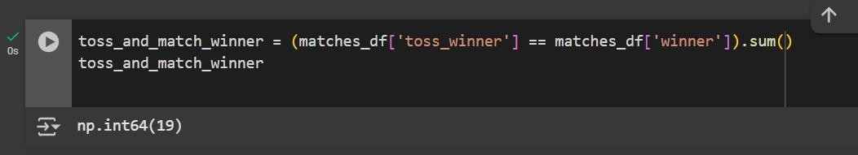

Identify the umpire who officiated the most matches.

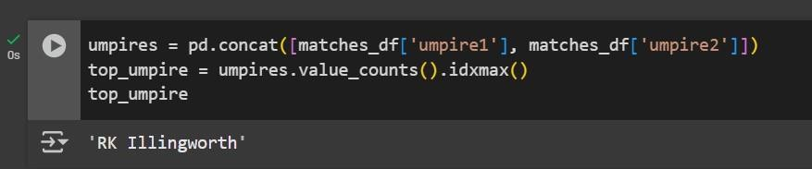

Calculate the average winning margin by runs.

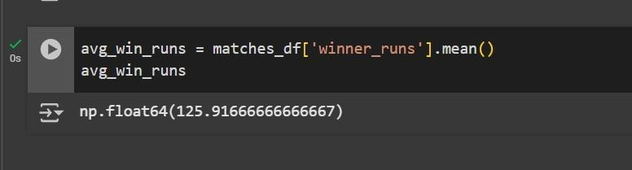

Calculate the average winning margin by wickets.

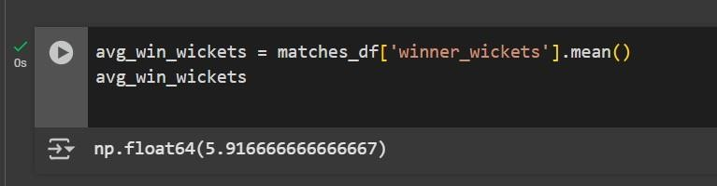

List all matches where the toss winner chose to bat.

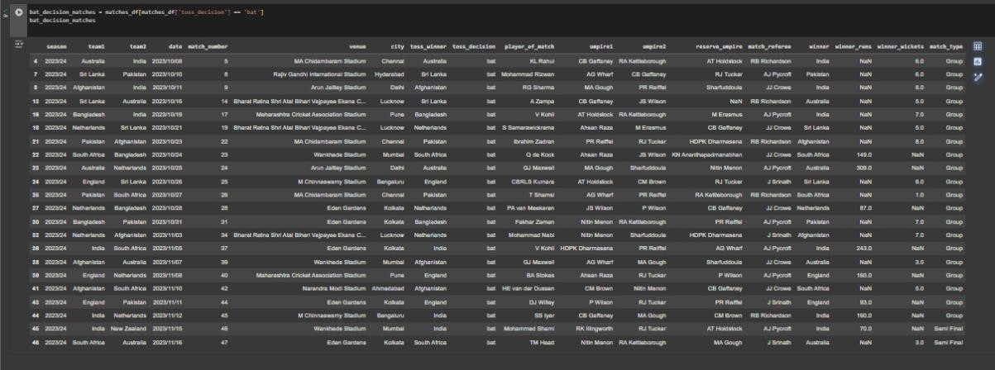

Find the number of matches played in each season.

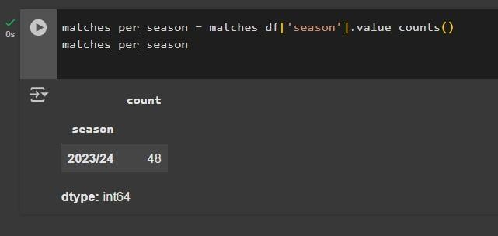

Find how many matches were played at each venue.

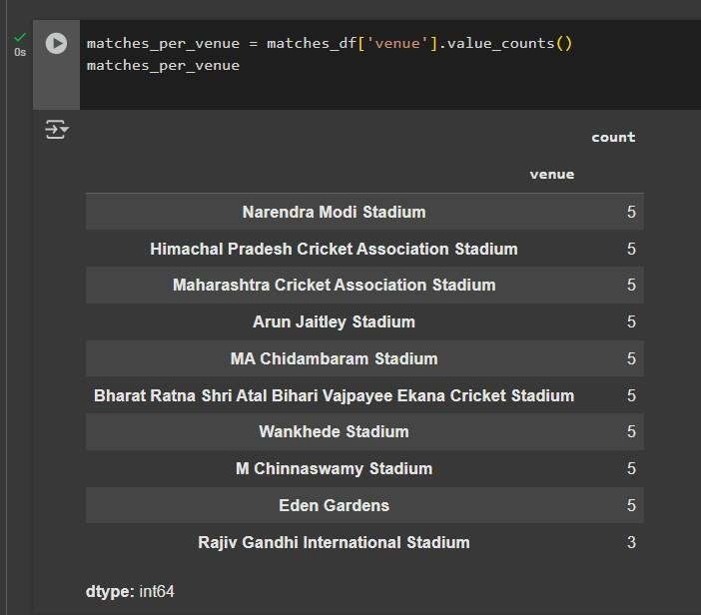

Find matches where toss winner and match winner were different.

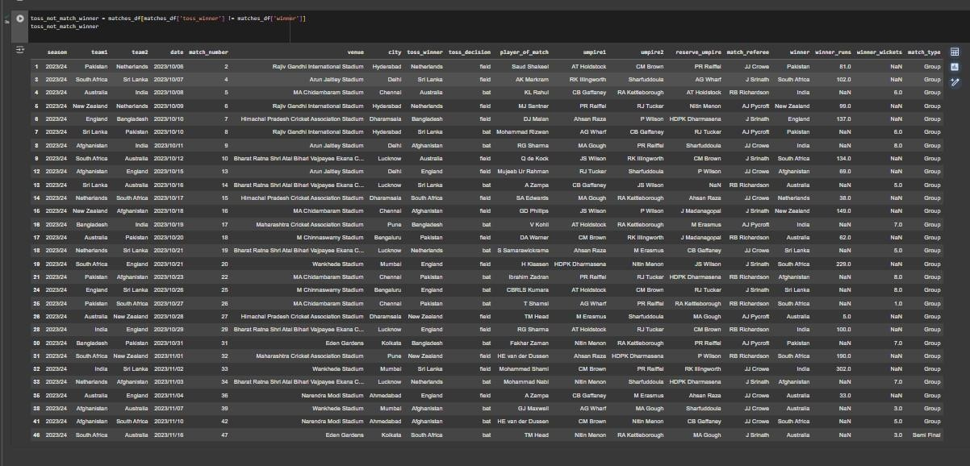

Find how many matches were "Group" matches.

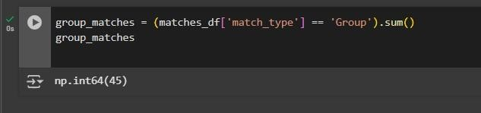

Find all cities that hosted more than 3 matches.

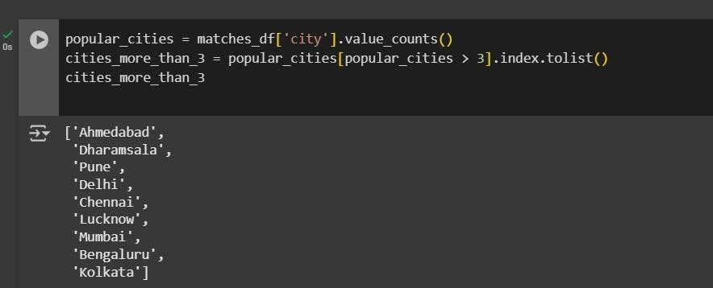

Find how many matches were played in Mumbai city.

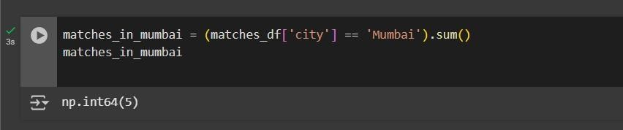

List all unique team names (no duplicates)

